University of Oxford
Department of Engineering Science
Workshop Practice Laboratory
Trinity Term 2019
Student’s Name: ………………………………………………….

READ THIS HANDOUT BEFORE ATTENDING THE LAB SESSION
Attendance |  | Satisfactory  Completion  (signed) | Comments
Signed | Dated

Location: Staff/Student Workshop Thom Building 4th Floor

Safety: You will be working on a machine tool, and
must be appropriately dressed. No long, loose
sleeves, scarves, jewellery etc. Bare toes and legs
are unacceptable.
Anybody inappropriately dressed
will be turned away !!!

What is the Staff/Student Workshop ?
The Staff/Student Workshop provides a facility for students and non-technician staff
of the Department to make parts for Fourth Year Projects, research and other
purposes. Students wishing to use these facilities should contact the head of the
Staff/Student Workshop, Maurice Keeble-Smith.

Safety Statement.
Lathes are potentially dangerous, and should be treated with great caution. The main hazard is that the operator is close to a workpiece which is rotating at high speed against a cutting tool. The main dangers are that material may be flung out or that the operator could come into contact with and be entrapped by the rotating parts.
Please note the following:
- It is essential that you are sensibly dressed for this lab: no long, loose sleeves, scarves, jewellery etc., as these may get caught in the machine.
- Long hair should be tied back.
- Bare toes and legs are unacceptable due to the risk of flying swarf
- Wear shoes that properly cover your feet – stout shoes, trainers and work boots are acceptable. Sandals, pumps, flip-flops, etc. are not.
- Use barrier cream to protect your hands from ingress of grease, oil and dirt
Anybody inappropriately dressed will be turned away !!!
- It is mandatory to watch the short safety video before using the machines. Anybody who turns up late and misses the video will be sent away and will need to make arrangements to come to another session.
- Please read the risk assessment at the end of this handout, and read the safety notices in the Staff/Student Workshop.
If you are in doubt – stop and ask
Learning Outcomes
Having completed the Workshop Practice Lab you should be able to:
- understand how to use a lathe safely for simple turning operations
- understand how to use micrometers.
- understand how parts can be machined to high precision
- understand how the basic features and geometry of a lathe enable it to produce flat and cylindrical surfaces.

Requirements
You will be required to attend one practical session in the Staff/Student Workshop. No preparation is required, other than reading this handout in full.
In the session you should satisfactorily complete the following:
- see the safety video and be given an appropriate safety talk.
- manufacture a ‘sample specimen’ to close tolerances.
Times
The lab is scheduled for 3 hours, in the afternoon: 14:00 to 17:00
Please check what day you are scheduled. Students should finish the lab within the allotted time.

DO NOT TURN UP LATE!
Lateness or Absence.
- If you know in advance that you will be unable to attend a lab session try to arrange a ‘swap’ with another student - if you do this, inform the Lab Organiser. If you cannot arrange a ‘swap’ please contact the Lab Organiser who may be able to arrange an alternate session.
- Be prompt: if you miss the safety video at the start of the session you will be sent away and will have to try to arrange another session, if this is possible.

LATHES

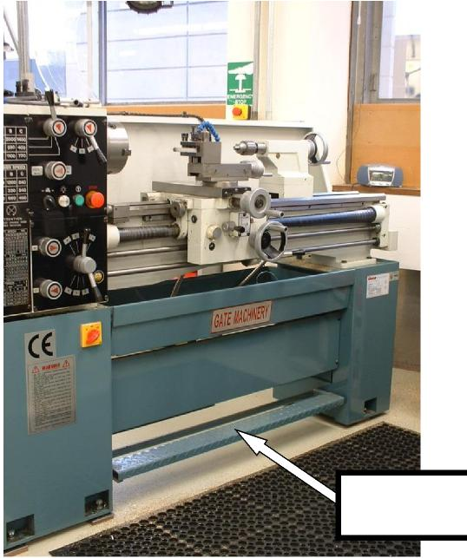
Emergency Stop
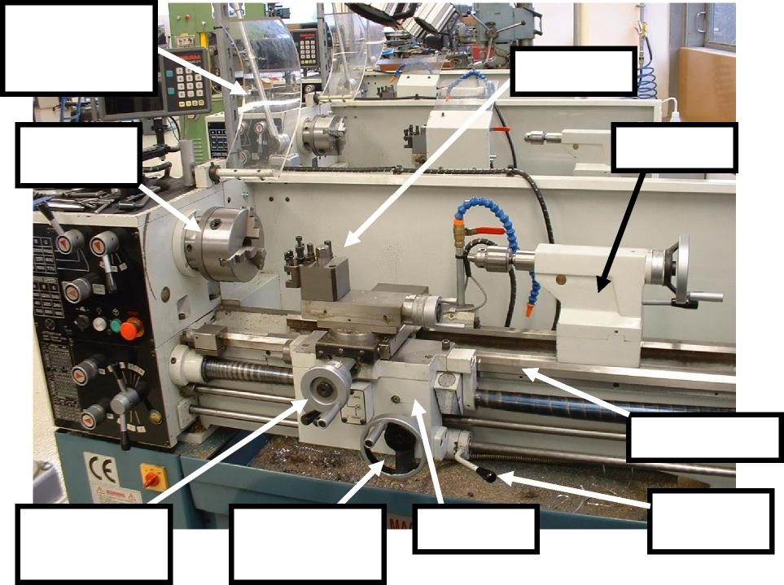
Interlocked
safety guard
(open)
Three jaw chuck
Cross-slide handwheel
Carriage handwheel
Carriage
Toolpost
Tailstock
Lathe Bed
Start/Stop Lever

Lathes are one of the oldest tools known to mankind, dating back to ancient Egypt, and are almost unique among machine tools in that the workpiece is rotated against a stationary tool.

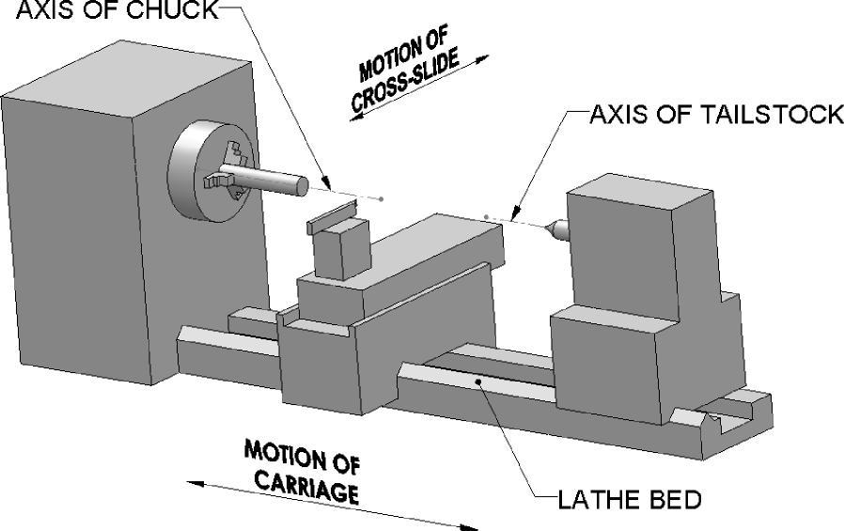
The key features of the modern metal-cutting lathe are -
- The workpiece is held in a chuck rotating in precision bearings
- A lathe bed
- A carriage which travels along the bed
- A cross-slide on the carriage
- The tool is usually mounted on a toolpost on the the cross-slide
- The tailstock is used either to hold a drill or reamer or it can be used with a ‘centre’ to support a long workpiece.
The carriage and the cross-slide can be moved manually, or can be driven (or fed) automatically. In addition, many lathes can be used for screw-cutting, where the carriage is driven by the feed screw which is connected to the chuck by a fixed gear ratio. Hence an M4 x 0.8 screw thread can be made by moving the carriage 0.8 mm for every revolution of the chuck.
The accuracy of a lathe comes from several key features
- The structure of the lathe must be stiff enough so that there is minimal distortion due to the weight of the workpiece and the cutting forces.

- The movement of the carriage along the lathe bed must be very linear
- The axis of the chuck must be parallel to the lathe bed
- The cross-slide must move perpendicularly to the axis of the chuck
- The tailstock must be co-linear with the axis of the chuck
- The chuck must be mounted on bearings which are stiff enough to give minimal distortion when subject to the highest cutting loads
- The workpiece must be held in the chuck in a way that will not distort it.
- The cutting tool must be held rigidly.
Lathe Tools
The Lathe tools you will be using have tips made from ‘High Speed steel’. These are supplied as blanks, and have the tips ground to a shape to suit the type of cut and the material of the workpiece, and to ensure good removal of swarf.
“High Speed” steel was introduced about 1900, and is a high carbon steel alloy containing tungsten and chromium. Before 1900, if cutting tools were used at too fast a speed (or with too deep a cut), they would get hot, become annealed and turn soft. ‘High speed’ steels would not anneal (and hence soften) at high temperature, and so could be used at higher speeds
One of the main reasons that these tools worked so well was the formation of tungsten carbide, and this can now be produced and used to make even harder tools. Some of these are known as ’tipped’ tools , which are made from steel, but have a small replaceable tip made from tungsten carbide.
When turning different materials, you should choose an appropriate tool and then use published data to choose an appropriate ‘speed’ (in m/sec; this depends on the diameter and rotational speed of the work) and the ‘feed’ (in mm/revolution)

Digital Readout.
The lathes you will be working on are fitted with Digital Readouts. These are for measuring the relative movements of the carriage and the cross-slide, and they can, if necessary, be ‘zeroed’ to give an absolute measurement. Note that the cross-slide position (“X” on the display) is automatically multiplied by 2 to give a diameter (and not a radius).
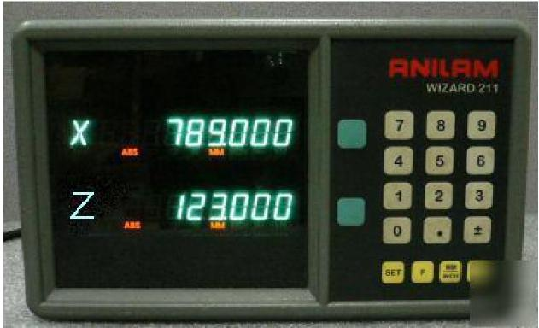
Coolant.
In a production environment, it is important to maximise the rate of cutting metal. To avoid the tool and work overheating, and to improve the removal of swarf, a coolant is used, which is typically an emulsion of water and oil. You will NOT be using a coolant in this exercise.

